BEEE LAB

Experiment-7- Liquid Crystal Display

***Concept Used :-***

The obstacle detector works on the principle of transmitting and receiving the Ultrasonic signal, and calculating the distance by measuring the time between transmitting and receiving the signal.

VCC terminal of ultrasonic sensor is connected to the 5V supply to get voltage.

TRIG pin is connected to the 9 number digital pin and it produces ultrasonic wave.

ECHO pin is connected to the 10 number digital pin and it receives the reflected back wave.

If the distance is greater than 20cm then lED glows.

***Learning and Observations :-***

1. Connection between the arduino and Ultrasonic signal transmitter IC 2. Concept of calculation of distance on the basis of signal transmission and receiving.

3. Coding to be done for Arduino.

4. Basic understanding of Electrical Connections.

5. What’s inside the Ultrasonic Signal Transmitter IC.

***Problems and Troubleshooting:***

Making a functional was a bit time taking as it becomes a bit confusing on arranging the wires.

Minors errors showed up in the code during the test run, which was trouble shooted by the correcting the above.

***Precautions:-***

Using multimeter to check whether the devices are damaged or not.

Correct sets Making correct connection

of instructions to be passed to successfully execute the experiment.

4. Port selection for Arduino.

***Learning and Outcomes:***

1)I have learnt to make circuits using breadboard, Arduino board and other equipment.

2)I have learnt to make other type of gadgets related to this concept.

3)I have learnt how we can use the Arduino board for doing various tasks.

4)I have learnt about the elements of Arduino board and its functions.

Liquid Crystal Display

Circuit Diagram:

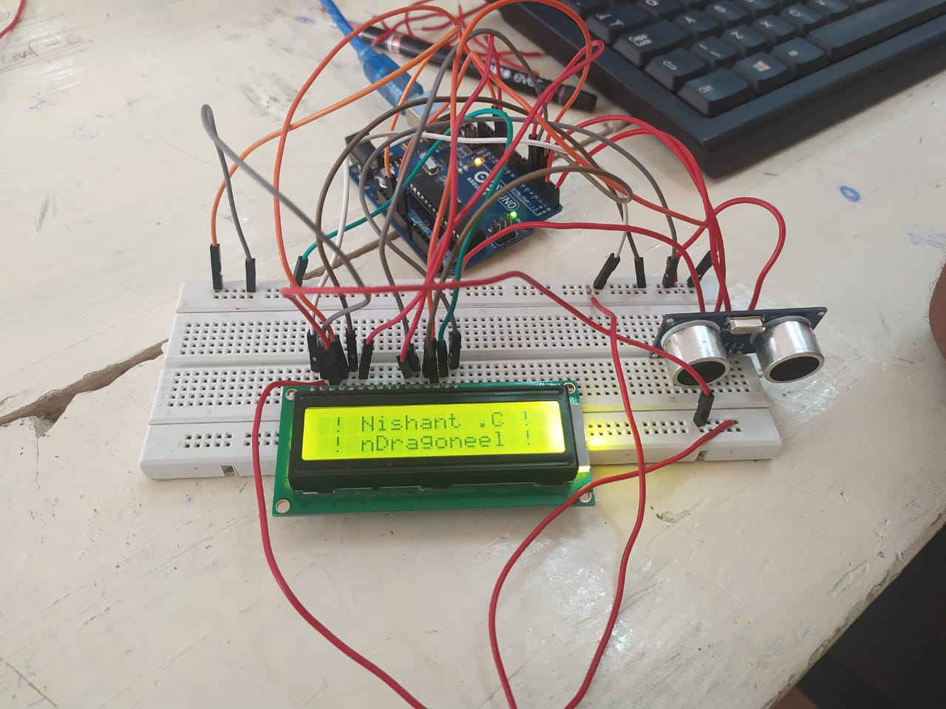

**Theory Concept Used:**

A character LCD display has 16 pins which are connecter in the same fashion as shown in the Circuit diagram. An LCD display can be programmed using the LiquidCrystal library provided in the arduino.

**Learning and Observations:**

Following observations were recorded during the experiment: • The lcd can at max display 16 characters in two rows. • lcd.print() function is used to display something on the character LCD.

**Problems and Troubleshooting:**

No problem was faced while performing the following experiment and it commenced successfully.

**Precautions:**

The following precautions need to be considered while performing this experiment:

• The connections of the USB in both the PC and the ARDUINO UNO board should be snug.

• The USB ports of the PC and the ARDUINO UNO should be in a working condition.

• The sketch should be logically and syntactically correct and germane to the experiment that needs to be performed.

• The correct serial port should be selected that is the one through which the ARDUINO UNO has been connected.

• Look for errors during compilation and upload of the executable to the ARDUINO UNO.

• Disconnect the digital 1 and 0 pins while uploading the program to the board.

• Do not open more than one instance of the ARDUINO IDE at a time.

• The connections should be intact in the correct holes of the breadboard.

**Learning outcomes:**

The various learnings as the outcome of performing the above-mentioned experiment are: • Use of the various functions of the LiquidCrystal library. • Connection of the LCD with ARDUINO UNO.